 | Positive Outcomes Support Plan

The POSP is to help you think about what you want to do in life and the steps you can take to achieve those things. Your key worker
will give you as much support as you need to do this, and there are some questions on the back pages to help get you started. You can
ask for a review of your support plan at any time.

Customers’ Name:: | Key workers’ Name | Date this plan was completed: | Review Date:
Service Address: |  | How often will the plan normally be reviewed:  At review, please complete a new support plan.
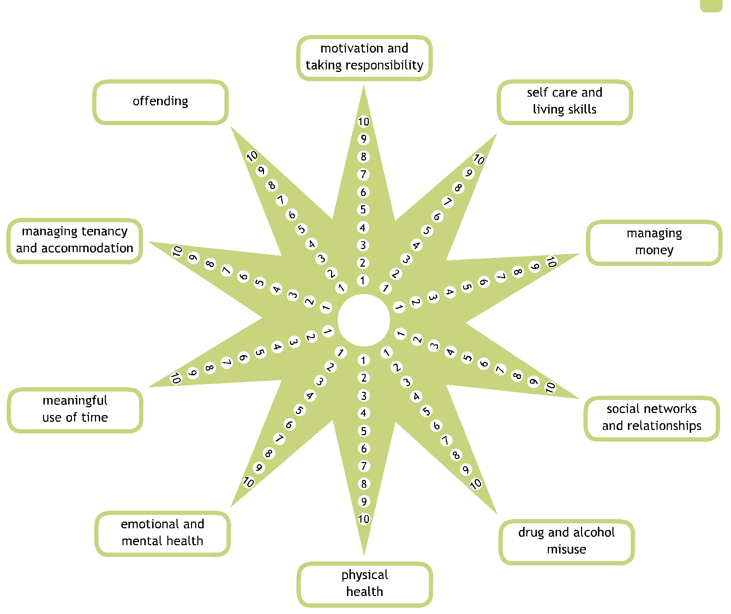

 | ACTION + SERVICES PROVIDED | WHAT ARE WE TRYING TO ACHIEVE
Support Plan | We will:  - Offer you a re-assessment of your needs & Support Plan Review at least once every six months.  - Will provide immediate re-assessment in the event of any significant changes in your well-being or safety.  - Will work in partnership with any other support services you have.  - Assist you to access other support services – e.g. social services, health etc. – where needed  You can request a re-assessment of your support plan at any time | To ensure your Support Needs are regularly reviewed with you.
Inform and Consult with you | We will:  - Keep you informed through a range of methods such as newsletters, leaflets, internet, letters, posters and more  - Consult with you through surveys, focus groups, forums, meetings, service user panel, and more. | To ensure you are well informed.  To ensure you are an involved part of the service and that you can express your views and ideas.
Treat everyone fairly and with respect of their Class, Colour, Beliefs, Religion, Race, Ethnic or National Origin, Disability, Sex, Age, Sexuality, Marital Status or Health. | We will:  - provide services that meet your needs  - provide clear information in plain English and use large print, languages other than English and audiotapes if needed  - work with all sections of the community  - review and monitor our services to make sure they do  - not unfairly discriminate anyone  - work with others to prevent harassment and violence  - Act quickly on complaints of unlawful discrimination and harassment. | Ensure we promote equal opportunities and provide fair access to services and meet the needs of all our service users
Putting things right | LHT Support Services will always try to provide the best services that we can.  If, however, you are not satisfied or concerned about any aspect of the service, please contact us & we will try to sort out your complaint immediately. If you are still not satisfied & wish to make a formal complaint we will:  - Acknowledge your complaints within 3 working days & respond within 10 working days.  Please request our complaints leaflet for more information | To ensure we are always providing you high standards

STAR CHART
Based on the information provided score your clients on a scale of 1-10, 1-2 stuck struggling, confused, 3-4 wants help, accepting help , 5-6 Believing, Taking Steps towards Goals, 7-8 Learning; making lots of progress, stable 9-10 achieved goal, no concern, self reliant.

Score | I AM About me, at this moment in my life  These questions are just examples.  - What is happening right now?  - What makes a good day for you? What makes a bad day for you?  - What is working in your life right now, and what isn’t working so well?

Score | I WANT My future, what I want in my life  These questions are just examples.  - What do you want out of life (in the long term)? What do you want to achieve really quickly?  - Who is really important to you? (where/ what is really important to you?)

Score | I CAN What I can do. What I can change.  These questions are just examples.  - What are your strengths? Who do you know?  - How much personal control or influence do you have over your goal?  - What are the steps to achieving it? Are they positive, challenging, and attainable?

ACTION PLAN ~ I WILL
What I want to achieve or maintain (personal outcomes) | How I choose to do this – my next steps | I will be supported by | I want it done by (date) | Progress check  Met / not met / progress

SUPPORT AGREEMENT

HOW I LIKE TO BE SUPPORTED
Who is going to help me achieve what I want to do, e.g. family members, friends, community networks, support workers etc ?

At London Housing Trust, I prefer to be supported by the following support worker or workers:
At the following times/ places:
Other ways you can best support me (please be explicit about medication and personal care here if these are relevant support areas):
As well as people in this team, who else would I like to share this plan with, e.g. other professionals or family members?

WORKSHEET

1 Positive Pathways 10 areas. Tick the areas covered in the support plan.

 | Tick |  | Tick
Who I am and what I like to do |  | Managing where I live
Developing my skills and finding purpose/ work |  | Creating the social networks and relationships I want
Keeping myself safe |  | Being physically active and healthy
Staying emotionally healthy |  | My relationship with drugs, alcohol and prescription medication
Managing money, including paying my rent and bills |  | Legal issues

2 Support workers should use this page to cover/explain any gaps in key support areas, to record SMART actions (where these are missing from the plan), person centred planning tools used, differences of opinion and other comments.

Please tell us about your involvement in the plan
 | I wrote my own support plan | My support worker and I wrote it together. | My support worker wrote the plan after meeting with me. | There was no customer involvement in this plan.
Tick the relevant box:

Customer Signature: | Date:
:  Staff Signature: | Date:
Manager’s Signature: | Date:

